- Remove the disclaimer added previously - seen at three places (TOP/Bottom/ Academic life -academic programme-IBprogramme

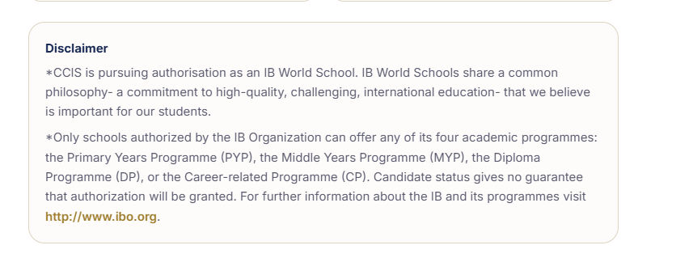
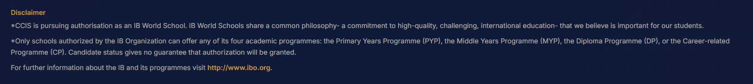

- Replace the candidate logo with Authorised IB logo- all places
New logo -
https://ibo.org/globalassets/new-structure/icons-and-logos/images/ib-world-school-logo-2-colour.png

https://ibo.org/globalassets/new-structure/digital-toolkit/images/pyp-programme-logo-en.png

- Remove candidate word Academic life -academic programme-IBprogramme

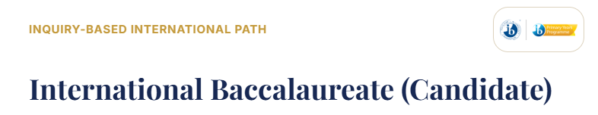
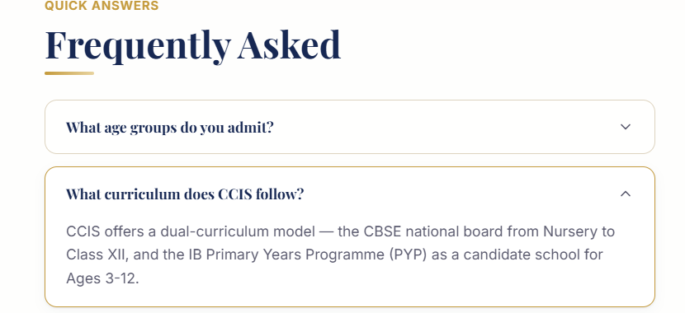
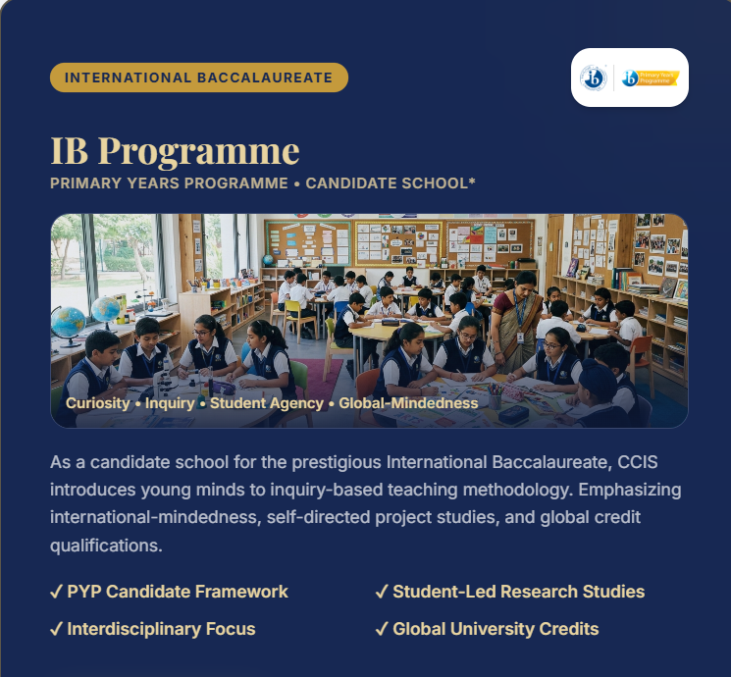

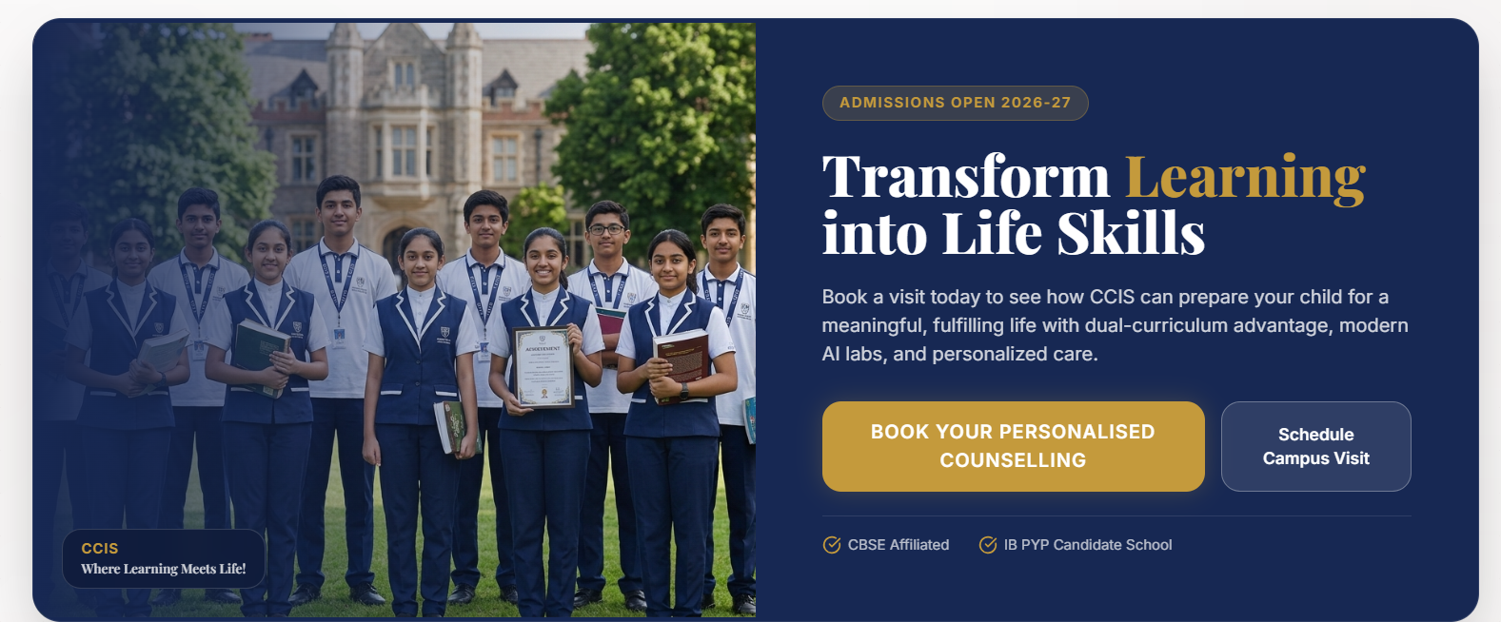
- IB Diploma and CBSE PRimary Section
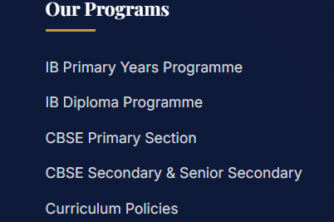

- Remove cambridge court group- it should be only CCGS

- Wrong info
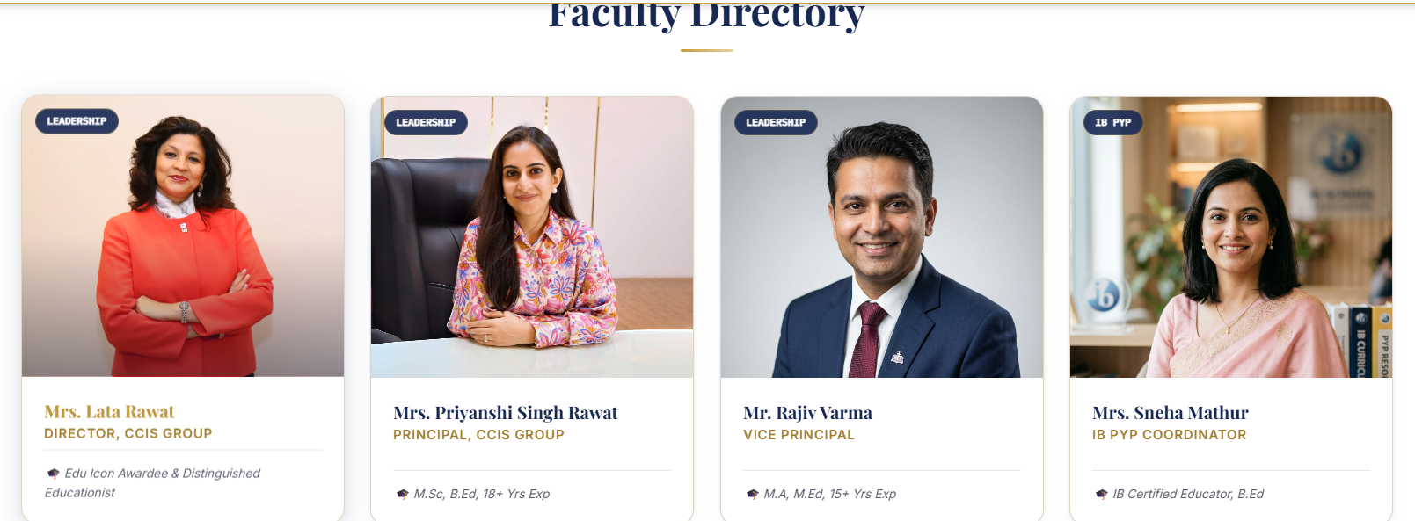


VISION MiSSiON - About CCIS - these are not ours

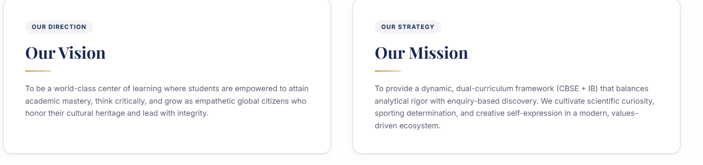
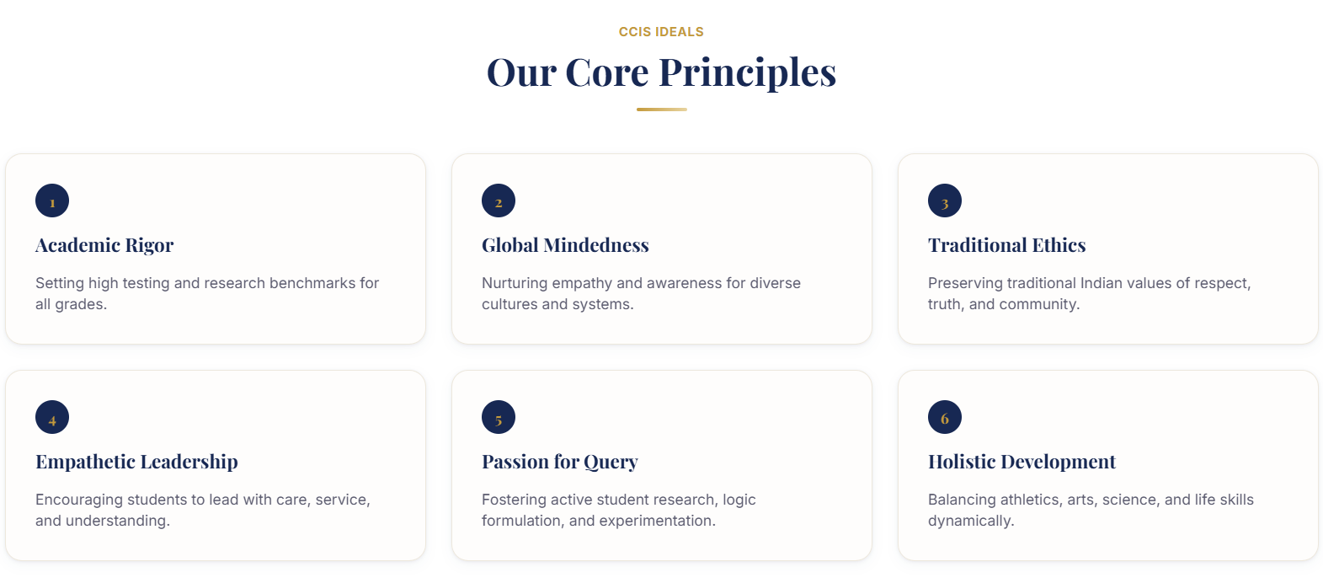

Home - this one is correct
